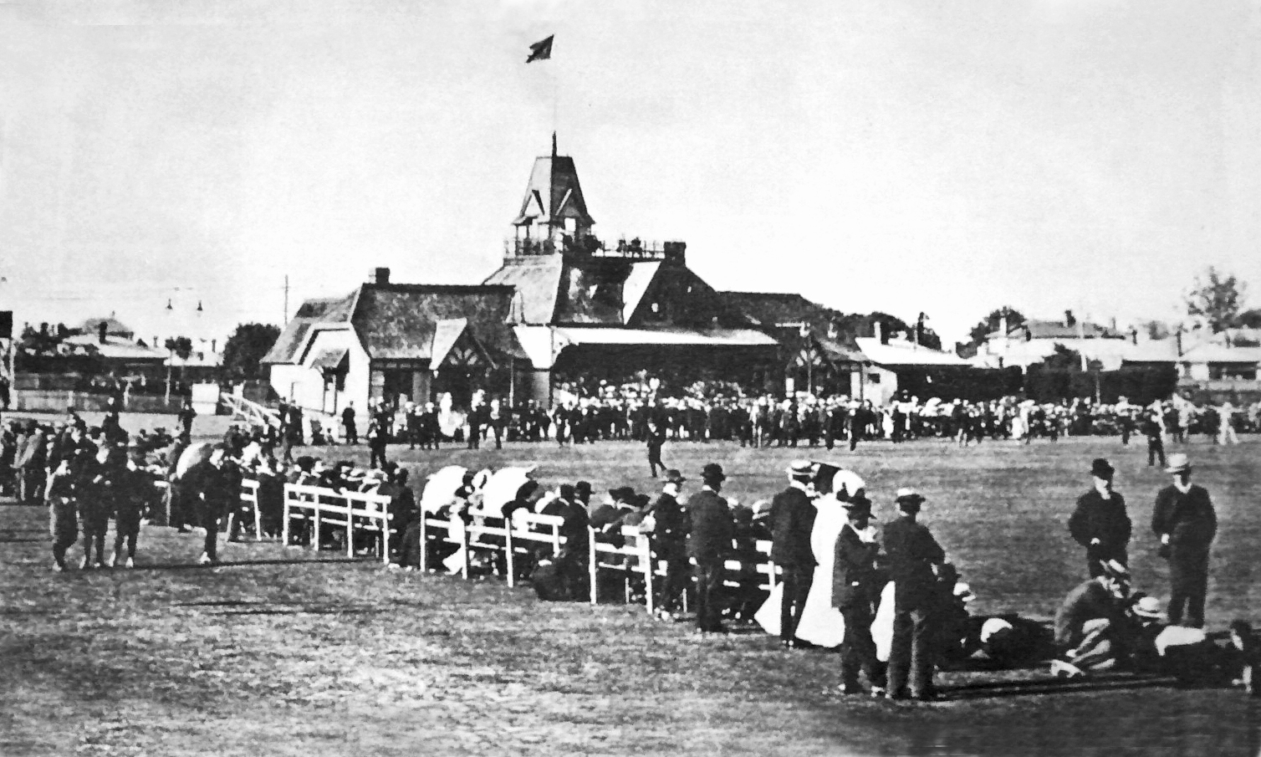

**Canterbury versus MCC 29 December 1906 Lancaster Park**

MCC 202 and 156. Canterbury 241 and 120 for 3. Canterbury won by seven wickets

Syd Callaway took 11 wickets for 157 and Keith Ollivier top scored with 78.